Our research question was to determine if it rained more in Seattle or New York City (NYC). This question was used to investigate if a NYC family’s hesitancy to travel to Seattle due to excessive rain was grounded in reality. To answer this research question, data was acquired from the National Centers for Environmental Information NOAA Climate Data from Jan. 1, 2020 to Jan. 1, 2024.

To analyze the data, the Seattle and NYC csv files were cleaned and merged into a single file. Null values were interpolated. Daily precipitation for each city was calculated by averaging the precipitation reports across all weather stations for each day, so that each city had only one precipitation data point per day.

To determine if NYC or Seattle had more rain, data visualizations were used to compare the two cities month to month, year to year, and summarily. A summary of the data reveals that NYC has a slightly higher average precipitation than Seattle. Seattle and NYC have similar medians represented by the ‘50%’ field, and Seattle has a slightly higher 75th percentile.

|  | count | mean | std | min | 25% | 50% | 75% | max |
| --- | --- | --- | --- | --- | --- | --- | --- | --- |
| **new york** | 1461.0 | 0.134 | 0.309 | 0.0 | 0.0 | 0.012 | 0.122 | 4.245 |
| **seattle** | 1460.0 | 0.116 | 0.233 | 0.0 | 0.0 | 0.016 | 0.132 | 2.71 |

Breaking down the data by year reveals fluctuation in NYC’s annual precipitation, while Seattle’s annual precipitation remains relatively stagnant. NYC had greater total precipitation in 2021 and 2023. In 2020 and 2022, the two cities had nearly the same amount of total precipitation.

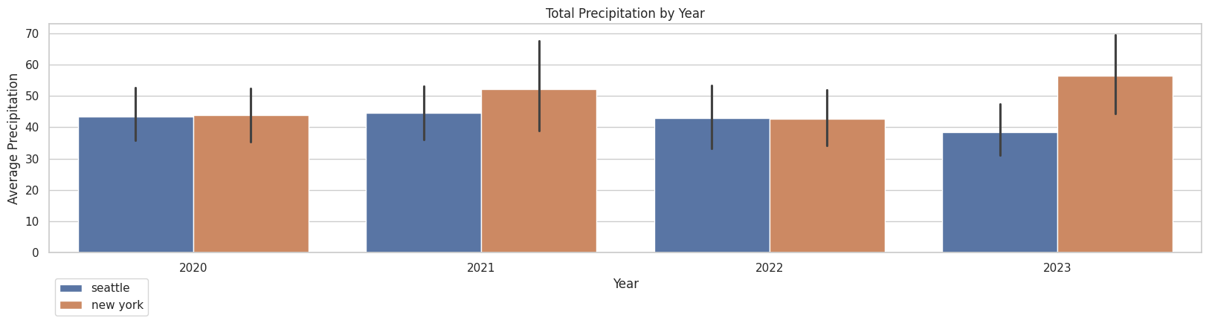

The below visual shows which months it rains more in each city. Seattle has greater average precipitation than NYC in January, November, and December. Meanwhile, NYC has greater precipitation in July, August and September.

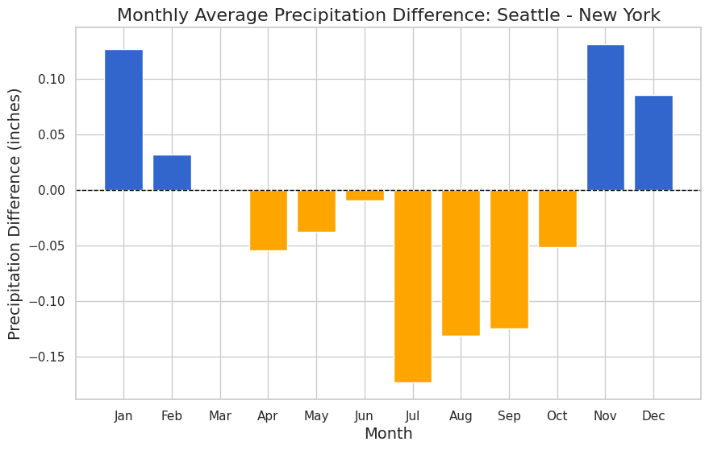

The original research question was crafted because a NYC family did not want to go to Seattle because they believed it rained more there. The above visualization demonstrates that on average it rains more in NYC 7 months out of the year. In conclusion, NYC and Seattle have similar amounts of rain, but demonstrate significant differences in average precipitation month to month.